MUSIC: Latin dance • Compose a 4-beat rhythm pattern to play during the instrumental sections. • Sing syncopated rhythms and recognise a verse, chorus structure. ‘March’ from The nutcracker • Develop active listening skills by responding to musical themes through movement. • Develop a sense of beat and rhythmic pattern through movement. • Experience call-and-response patterns through moving with a partner From a railway carriage • Improvise and explore a variety of ways in which words can be used to create music. • Create word rhythm patterns and longer sequences and explore ways to communicate atmosphere and effect. Singing with Mr Dalglish and recorders with Mr Melville.  Questful RE: Called by God We aim to give children an opportunity to consider what it means to be called by God. Easter To increase pupils’ knowledge and understanding of the Easter story, exploring the feelings evoked then and now by different events throughout Holy Week. To discover how the services held in churches during Holy week reflect the sadness and joy.  PSHE: KIDSAFE - Keeping Safe, Healthy Lifestyles and 1Decision programme covering: Touch, Relationships, Making Friends Online, Computer Safety, Grief and Feelings & Emotions  MODERN FOREIGN LANGUAGES – FRENCH: Show understanding of words & phrases. Appreciate stories and songs, poems & rhymes  Broaden vocabulary.  HOMEWORK: Children have reading homework every night / spellings, handwriting and times tables to learn on a weekly basis.  Monday – Spellings/Literacy Tuesday – Numeracy  Homework to be handed in the following week.  VISITS/ ENRICHMENTS: Collective Worships & Assemblies by external visitors to our school including Food Bank and Church leaders from around Cockermouth.  PARENT TEACHER INTERVIEWS: There will be Parents Teacher Interviews held in the February. | All Saints’ CE Primary School  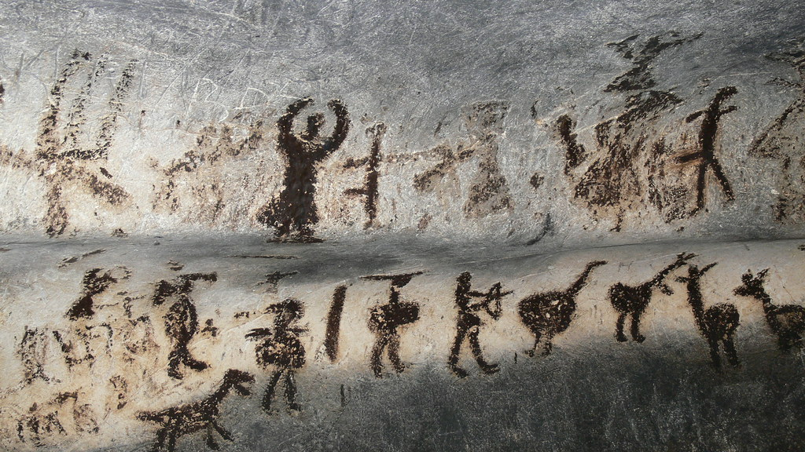  Y3 Curriculum Information  Spring Term  Theme – Stone Age  North America  Miss Y S Dykes  ydykes@allsaints.cumbria.sch.uk
Year 3 Work for Spring Term – Stone Age/North America  LITERACY STRATEGY: Ug / Stone Age Boy (Narrative)/ How to wash a Woolly Mammoth (Instructional)  Phonics – we will be following the Floppy Phonics to catch-up with any Phonics missing from Year 2.  Reading Use knowledge to read ‘exception’ words. Read range of fiction & non-fiction. Use dictionaries to check meaning. Prepare poems & plays to perform. Check own understanding of reading. Retrieve & record information from non-fiction books. Discuss reading with others. Discuss characters’ feelings and behaviour. Compare types, forms of humour. Compare and contrast work by the same author. Be aware of authors and discuss preferences and reasons for these. Read examples of letters written for a range of purposes.  Writing Use prefixes & suffixes in spelling. Use a dictionary to confirm spellings. Write simple dictated sentences. Use handwriting joins appropriately. Plan to write based on familiar forms. Rehearse sentences orally for writing. Use a varied rich vocabulary. Write non-chronological reports about Egyptian life. Write letters, notes and messages. Retell the main points of a story in sequence. Assess effective of own and others’ writing.  Grammar Distinguish between 1st and 3rd person accounts. Use a range of connectives. Use a perfect tense (past, present, future). Use range of nouns & pronouns. Use time connectives. Introduce speech punctuation. Know Language clauses (a clause has a verb & subject and can be independent (simple sentence) or dependent (joined by a comma or connective).  Speaking & Listening Give structured descriptions. Children participate in conversation activities. Consider & evaluate different viewpoints. DRAMA opportunities hot seating and role play.  MATHS – White Rose Curriculum  Multiplication & Division, Money, Statistics, Length & Perimeter.  WARM UPS – include revisiting Place Value & Number, Fractions, Geometry, Mental Maths, Multiplication & Division, Measurement and Statistics. | SCIENCE: Rocks & Soils Investigate the rock cycle. Find out about how fossils are formed. Investigate materials: stone vs bronze vs iron. Learn about different layers of soil. Investigate the best material for new trousers for Ug. Learn about prehistoric animals and their food chains. Use caves as a starting point for learning about light and shadows.  Teeth and Eating All animals need to feed: varied diet. Teeth: molars, canine incisors. Shape of teeth and their purpose. Observations and comparisons of teeth. We have 2 sets of teeth in a life time. Healthy gums.  COMPUTING: Computing Thinking: We Are Games Testers. Programming: Scratch.  HISTORY: Stone Age To find out what happened in the Stone Age. Look at different homes from the Palaeolithic, Mesolithic and Neolithic times. To find out what people ate in the Stone Age and how their diet changed. Consider life in the Stone Age and how it compares to life today.  GEOGRAPHY: North America USA: Locate North America on a world map and explore the landscape. Identify countries in N America. Explore the Rockies. Mount St Helens. Compare landscapes of different US states. Compare New York City, New York State and where I live.  Please bring PE bag in and leave on peg for TUESDAYS  PE: Invasion Games – Football, Hockey & Rugby To send & receive a ball on the move, with stick, or feet, or passing with 2 hands. To move & then stop when in possession of the ball. To develop handling skills in a small competitive game.  ART: Gestural Drawing with Charcoal Children discover how to make drawings that capture a sense of drama or performance using charcoal. . Artists Heather Hanson, Edgar Degas and Laura McKendry.  D&T: Researching, designing a Mechanical Toy using the Pneumatic Mechanical System.

